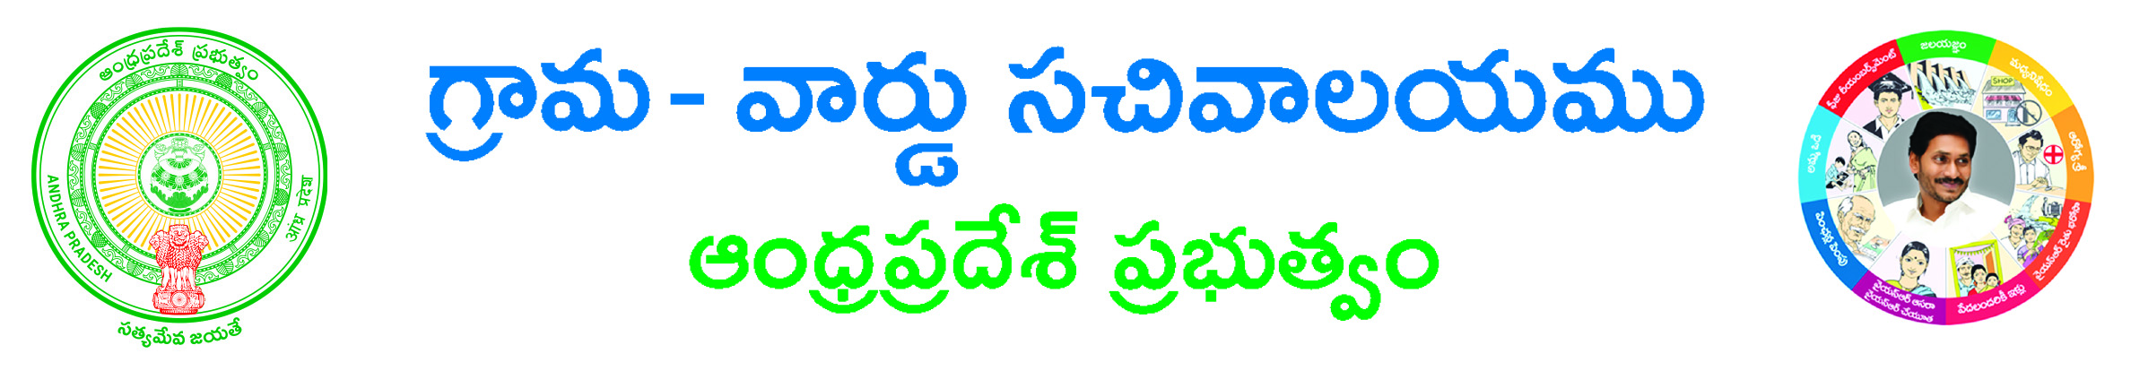
Late Registration of Death Application Form

To
The Revenue Divisional Officer,
___________________ Division,
___________________ District.

Respected Sir,

Sub: - Request for Issue of the Death Registration of my _______________________-regarding.

I, _____________________________S/O / D/O / F/O / M/O / W/O_______________________________,
Age ____ years, occupation: _________, R/o H.No. ______, Near______________, ____________ Mandal, ________________Dist. Andhra Pradesh submit the following few lines for your kind perusal and sympathetic favorable consideration please.

That my _________________________ name is ___________________ Age ________ Years, was died on_____________ (dd/mm/yyyy) at H.No._____________, Near ____________ __________________, ___________________ Mandal/Municipality, ___________________ Dist. Andhra Pradesh. The information regarding death of my ____________________was not informed to the local Births and Deaths Registration Authority of _________________________ Mandal/Municipality. Hence the name of my ________________ is not recorded in the Birth & Death Register of ______________________ Mandal/Municipality.

That my Family requires death certificate for _________________ purpose urgently.

I enclosed here with Non availability certificate issued by the GP or Municipal Commissioner, Ration card copy and Self Affidavit.

Therefore I request you kindly to issue necessary orders to Commissioner, Municipal Council__________________ to record date of death of my _______________and issue Death Certificate as above at the earliest.

Contact Details: Yours faithfully,
Landline Number:
Mobile No: Signature of the Applicant
Email ID:

Procedure: (following to be enclosed)
1) Physical Document*
2) Non availability certificate issued by the GP or Municipal Commissioner#
3) Ration card copy#
4) Self Affidavit#

*-mandatory # -any one of them

